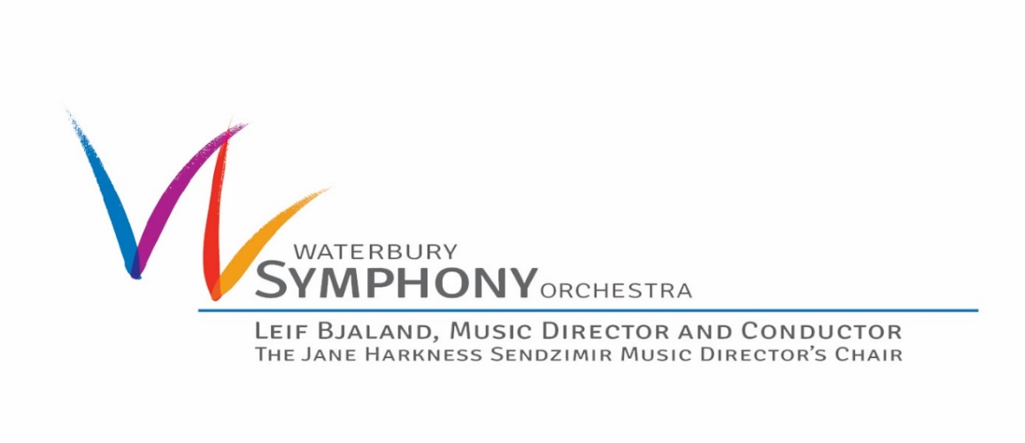
FOR IMMEDIATE RELEASE
CONTACT: Andrea Nyquist, Marketing & Engagement Manager
PHONE: (O)203-574-4283, (M)719-640-2966
EMAIL: marketing@waterburysympony.org
WEBSITE: www.waterburysymphony.org
FOR IMMEDIATE RELEASE
Tuesday, September 8, 2020
Waterbury Symphony Orchestra celebrates music and resilience with Vivaldi’s Four Seasons at Hollow Park
WATERBURY, CT – Waterbury Symphony Orchestra presents Antonio Vivaldi’s (1678-1741) Four Seasons, Saturday, September 26, 2020 at 3:00 pm, in its first live concert since the Covid-19 pandemic began in March, at Woodbury’s Hollow Park.
Vivaldi’s most famous composition, The Four Seasons is comprised of four violin concerti, each of which gives musical expression to a season of the year. The piece is an opportunity to showcase members of the WSO’s string section and will feature two guests who have appeared with the Symphony previously: violinist, Sirena Huang and conductor, Ryan Tani. Huang, a graduate of Yale School of Music, debuted with the WSO in 2010 and this summer performed in the WSO’s virtual concert, Variations on a Fourth! Guest Conductor, Ryan Tani, a Conducting Fellow at the Yale School of Music, worked with the WSO's Side by Side music education program that pairs students in ASAP with musicians from the Waterbury Symphony Orchestra. "I am so pleased that Ryan Tani has been invited to work with the talented musicians of the Waterbury Symphony Orchestra. This engagement continues the partnership between Yale School of Music and the WSO. How thrilling it will be for the Greater Waterbury community to enjoy some live music during these unusual times,” says Jeffrey Mistri, General Manager of Yale Philharmonia.
“While no one knows what the months ahead may look like, we are excited to celebrate the resilience of our community through the shared experience of a live classical music concert,” explains WSO Executive Director, Robert Cinnante. “This music, set against the backdrop of Hollow Park, is the perfect opportunity to bring our community back together.”
Admission is $25 for adults and $10 for children 17 and under. Tickets are available at waterburysymphony.org or 203-574-4283. Advance tickets only. There will be no walk-up sales at this concert. Rain date: Sunday, September 27, 2020 at 3:00 p.m.
The WSO has developed concert guidelines in accordance with the CT Department of Economic and Community Development (DECD) so that everyone can relax and enjoy the music. Capacity is limited and this concert is expected to sell out. Attendees will be required to wear masks and practice social distancing. A full list of guidelines can be found on the Symphony’s website at www.waterburysymphony.org.
This concert is sponsored by:
Presenting Sponsor: Thermo Conductor Services
Media Sponsors: Republican American and WATR Radio
Artist Sponsors: Isabelle Curtiss and Ion Bank
Guest Conductor Sponsors: Susan Suhr and Marina Viale
Special thanks to St. Paul’s Episcopal Church, Woodbury
About Sirena Huang
Praised by The Baltimore Sun for her “impeccable technique…deeply expressive phrasing…and poetic weight," Sirena Huang is one of her generation’s most celebrated violinists. She brings not only technical brilliance and powerful artistry to the stage, but also a profound sense of connection to her audience.
Sirena has been the recipient of numerous accolades and awards. Most recently, in February of 2017, Sirena was awarded First Prize at the Elmar Oliveira International Violin Competition and in March, she was awarded the winner of the New York Concert Artist. In 2009, she won First Prize Gold Medalist of the 6th International Tchaikovsky Competition for Young Musicians. She won First Prize and the Audience Award at the Cooper International Competition in 2011. That same year, she was also named the first Artist-in-Residence of Hartford Symphony Orchestra. In 2013, she was awarded the Hannloser Prize for Violin at the Verbier Music Festival in Switzerland. She is also a top prize winner at Singapore International Violin Competition as well as the Shanghai Isaac Stern International Violin Competition.
Sirena made her solo debut with the National Taiwan Symphony Orchestra in 2004 at the age of nine, and has performed in seventeen countries across three continents. She has been featured as a soloist with more than fifty prestigious ensembles, including the New York Philharmonic, Cleveland Symphony Orchestra, Baltimore Symphony Orchestra, Shanghai Symphony Orchestra, Russian Symphony Orchestra, Singapore Symphony Orchestra, and the Staatskapelle Weimar in Germany. She has appeared as a guest artist at the Verbier Music Festival, Marlboro Music Festival, Ravinia Music Festival, Aspen Music Festival, Eastern Music Festival, Sarasota Arts Series, Albuquerque Chamber Music Festival, “The Great Music for a Great City” series in New York City, and many others.
Motivated by a deep wish to inspire peace and harmony with her music, Sirena has performed before world leaders, thinkers and humanitarians, including President Obama and Elie Wiesel. At age eleven, she gave a TED talk that garnered more than 2.5 million views. In 2006, she received the honor of playing for His Majesty King Abdullah II of Jordan and thirty Nobel Prize Laureates at the World Peace Conference held in Petra. In 2007, under the invitation of former Czech Republic President Havel, she played in the Opening Ceremony of the “Forum 2000 World Conference” in Prague. In 2008, she was invited to perform during the ceremony in which the Elie Wiesel Foundation for Humanity presented its Humanitarian Award to President Sarkozy of France.
In addition to her TED Talk in 2006, Huang has been featured on numerous radio and television broadcasts, including WQXR’s McGraw-Hill Young Artists Showcase and NPR’s “From the Top" as well as several interviews with WNPR, CNBC, WTNH, WTIC, WB20 and Beethoven Radio.
About Ryan Tani
A driven and versatile conductor, Ryan Tani has been praised for his compelling musicianship in a wide range of symphonic and choral repertoire. Ryan currently serves as the Orchestral Conducting Fellow for the Yale Philharmonia, where he studies under the guidance of Peter Oundjian. He also serves as the Music Director of the Occasional Symphony in Baltimore. In 2015, he was declared the winner of the ACDA Undergraduate Student Conducting Competition at their national conference in Salt Lake City, Utah.
An advocate of new and early music, Ryan has stayed active as conductor and performer for new compositions by emerging composers. He is resident conductor of the New Music New Haven series, where he collaborates, under guidance of Aaron Jay Kernis, with Yale University composition students and faculty.
During his time in Los Angeles, Ryan served as Co-Founder and Music Director of the Concerto Chamber Orchestra where he helped shape the orchestral scene in the Los Angeles area by providing high-level performance opportunities to student musicians of all majors. He has also served as Assistant Conductor of the Chesapeake Youth Symphony Orchestra in Annapolis, where he was the principal conductor of the Preparatory Orchestra, and as Conducting Fellow for the Montgomery Philharmonic.
Ryan is a graduate of the Peabody Institute where he studied conducting with Marin Alsop and Markand Thakar, and of the University of Southern California, where he studied voice with Gary Glaze. Ryan remains an active tenor in New Haven, and plays violin, jazz piano, and viola da gamba for enjoyment.
About Waterbury Symphony Orchestra
The WSO builds connections across the region with exploratory concerts, events, and educational programs. The WSO maintains a firm commitment to produce programs that are of value to its patrons, participants and community partners. This commitment is rooted in the Symphony’s core belief that music education and shared cultural experiences are essential to creating community. Founded in 1938, the Symphony has assembled talented musicians across New England and the Tri-state area to perform throughout Northwest Connecticut. Leif Bjaland has served as Music Director and Conductor of the WSO since the 1994-1995 season. The Symphony has been the Orchestra-in-Residence at Naugatuck Valley Community College since 1992.
###

